# Create Files

### Create files in your local directory

Before create files in GitHub for Windows

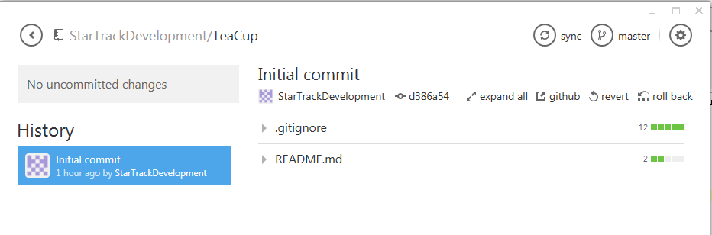

### You can open your repo directory in explorer

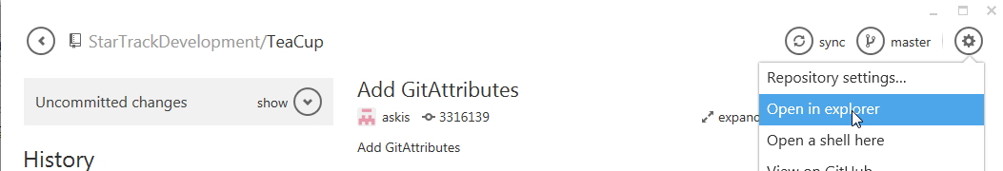

### Create or copy files to your local directory

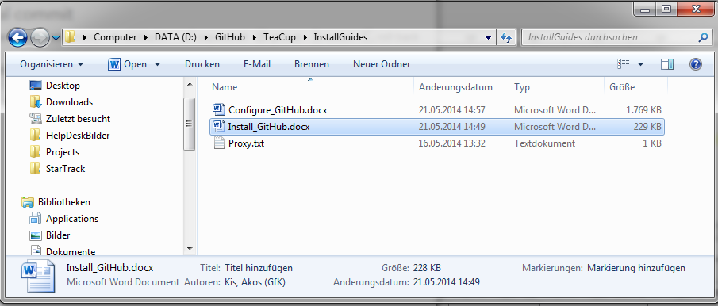

### Click on uncommitted changes

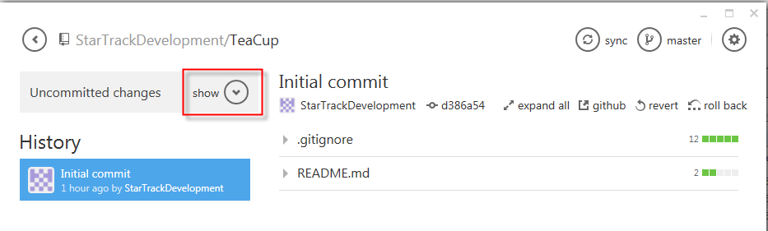

### The new files are there

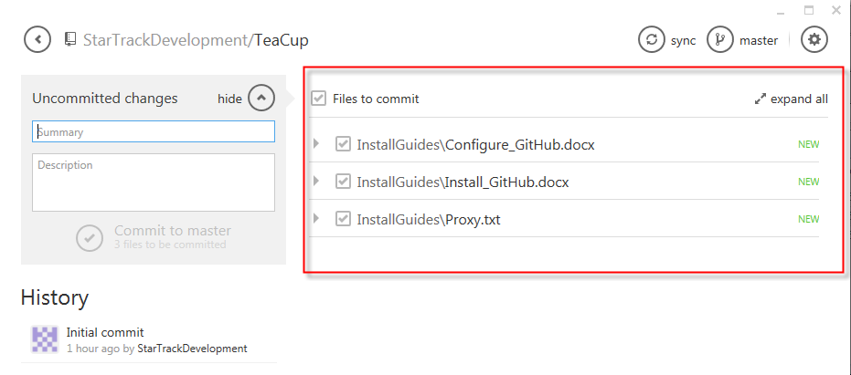

# Commit changes

### Add commit message

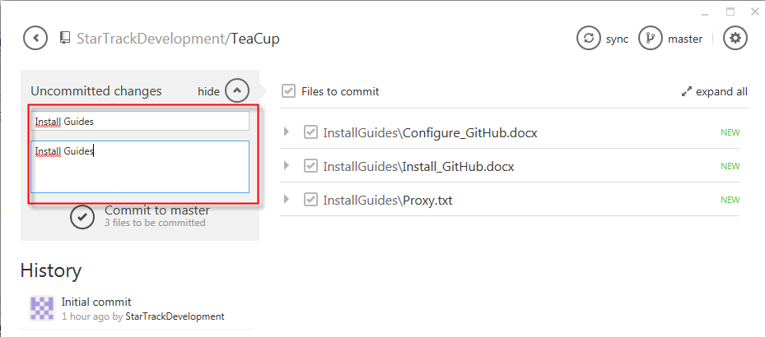

### Click on “Commit to master”

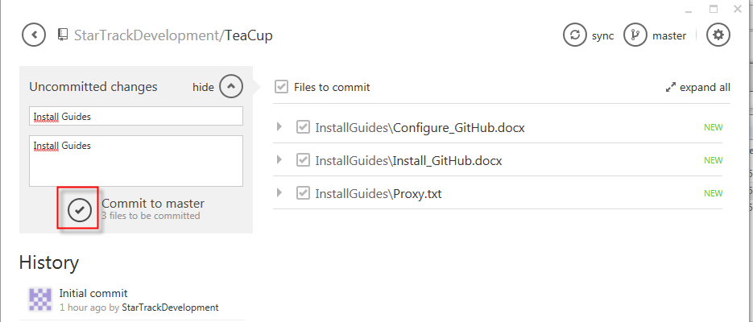

### We have commited the changes, but only local

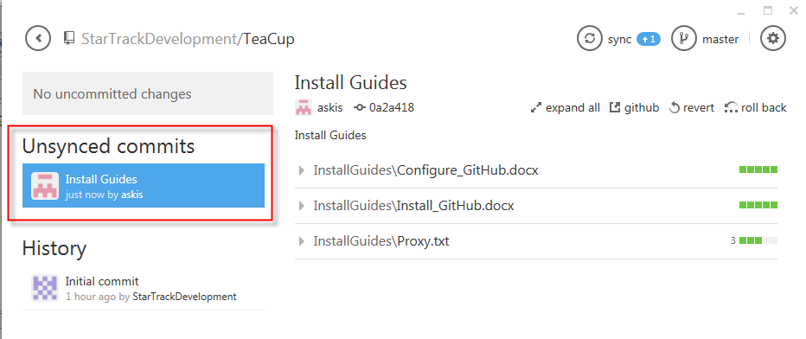

### Our changes does not exist on GitHub yet

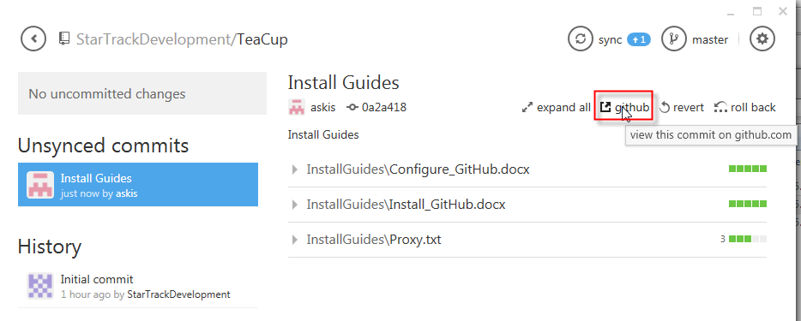

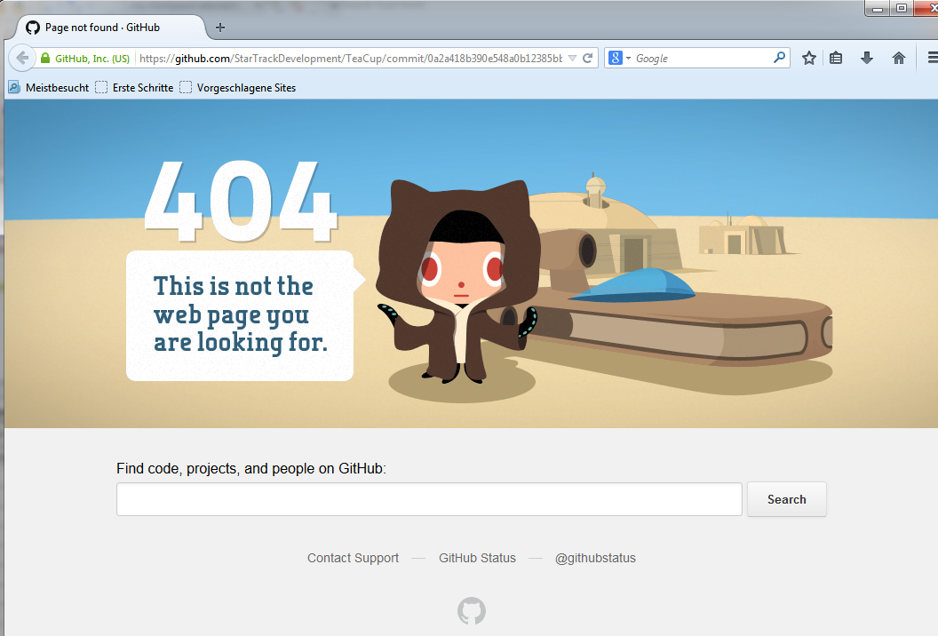

### Push our changes, click on sync

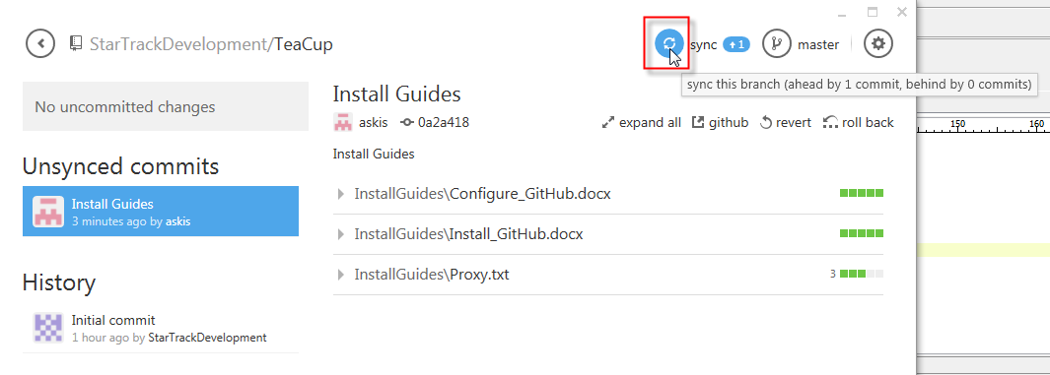

### Changes are in History now

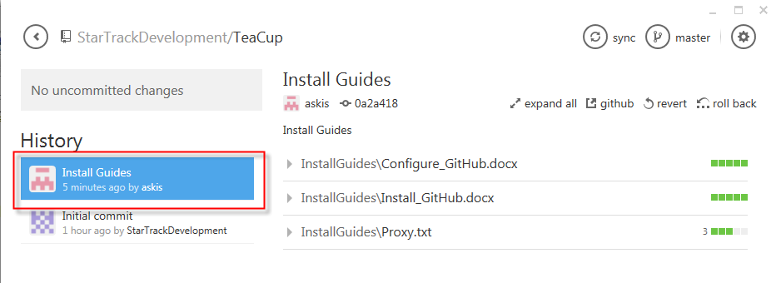

### We should see our changes online

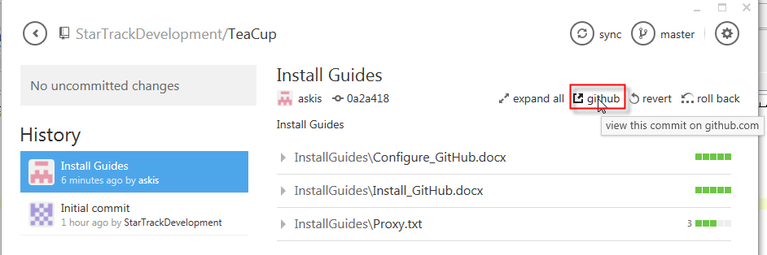Yes, we have install guides online now

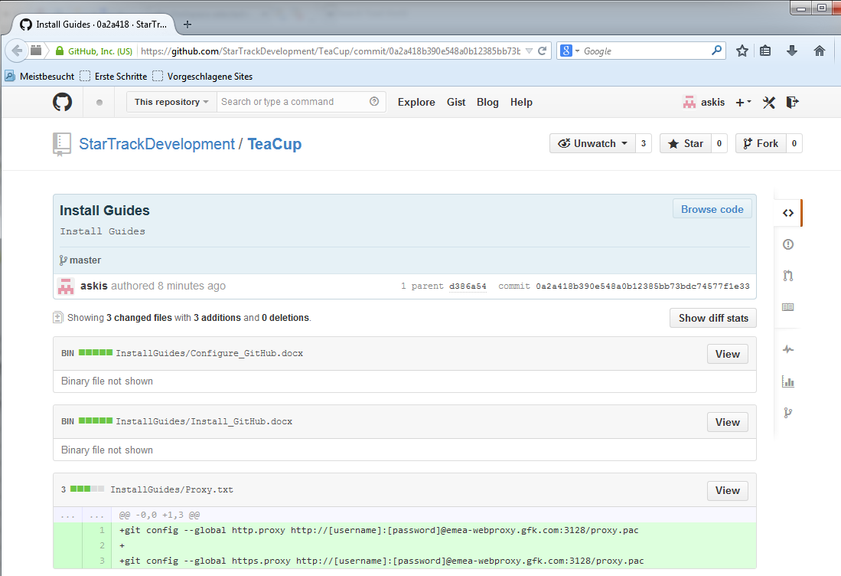

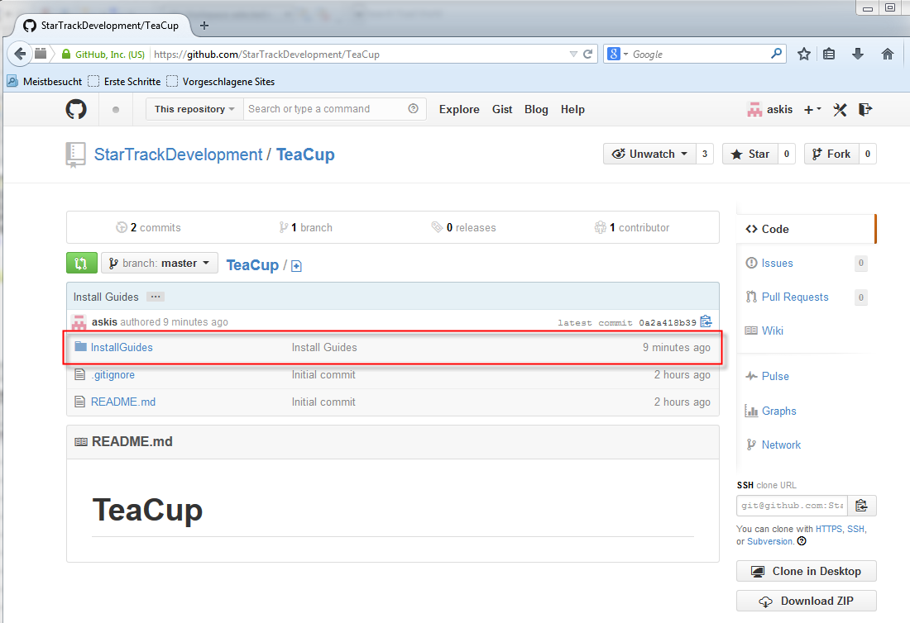

# Show difference

### Everything is synchronized, no changes exist

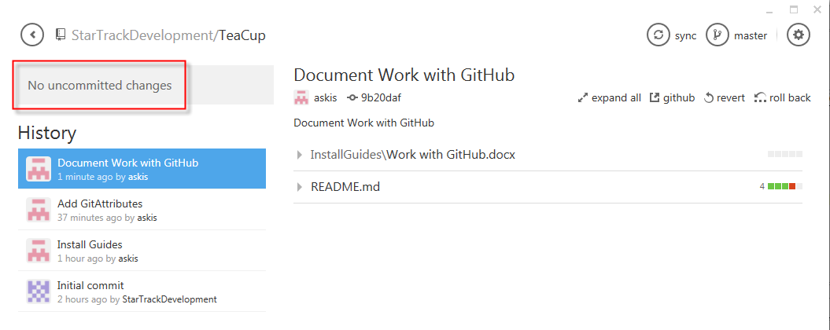

### Open ReadMe.md in any editor your choice

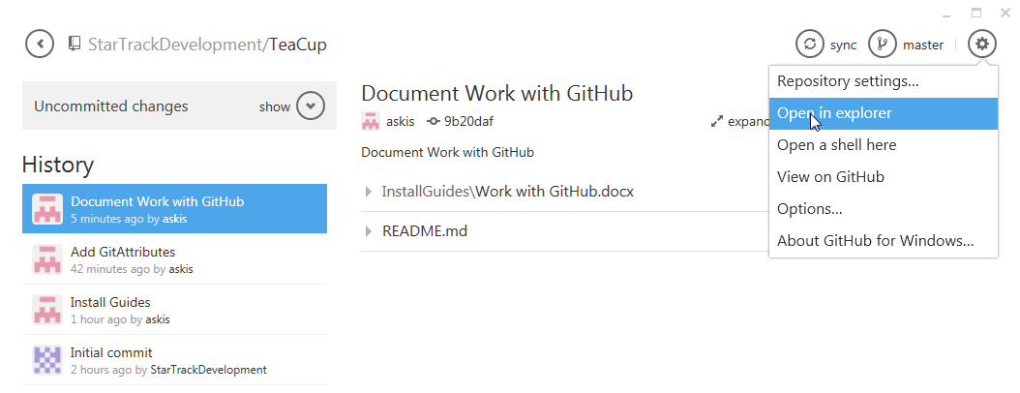

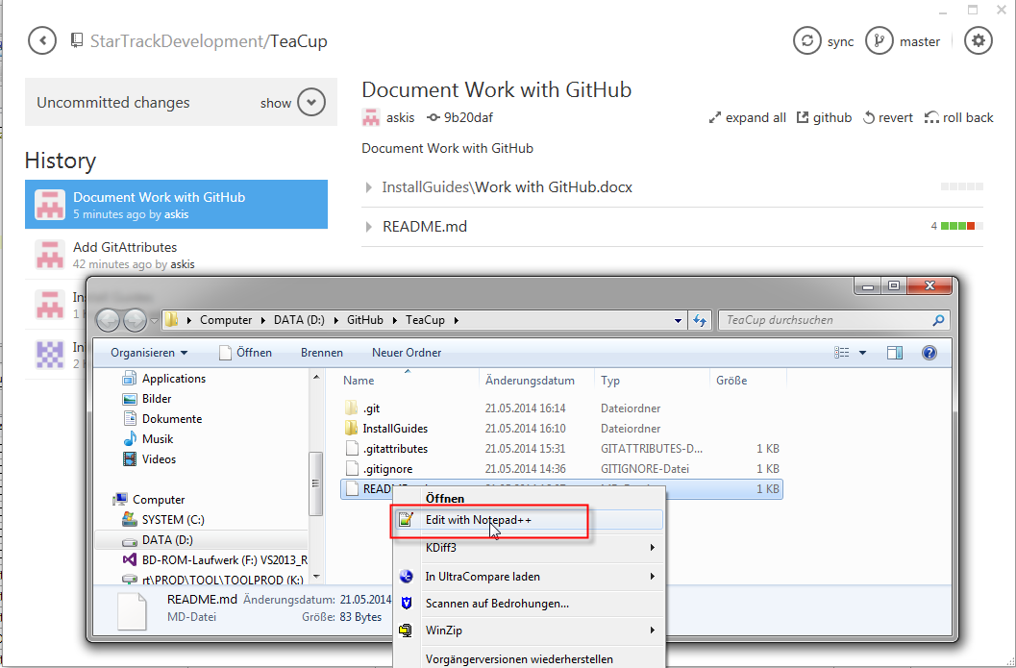

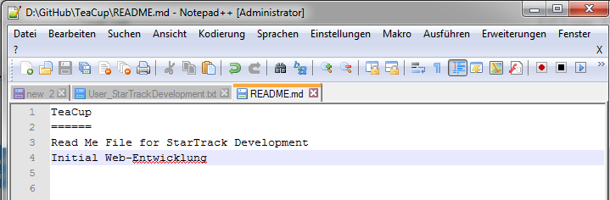

ToDos:

1. “Entwicklung” is German, should be Development
2. Delete line 3
3. Add new line with text “Diff example”

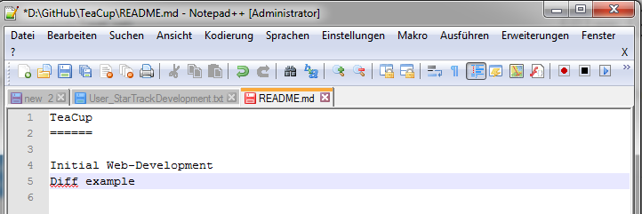

### Save the file and go back to GitHub for Windows

There are uncommitted changes

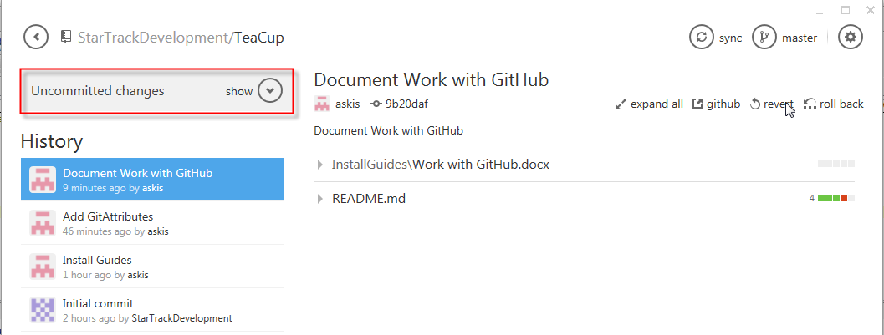

### Show them, click on “show”

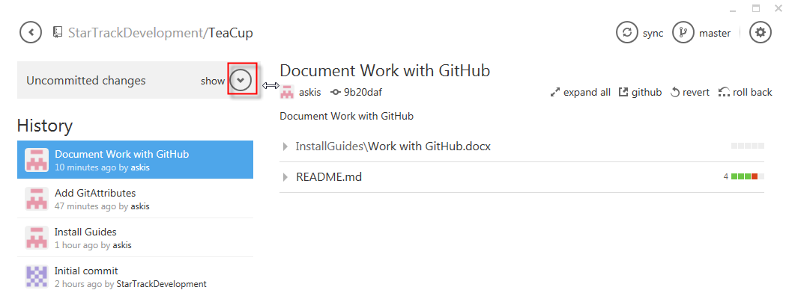

### Our ReadMe.md is there, git recognized that we made changes

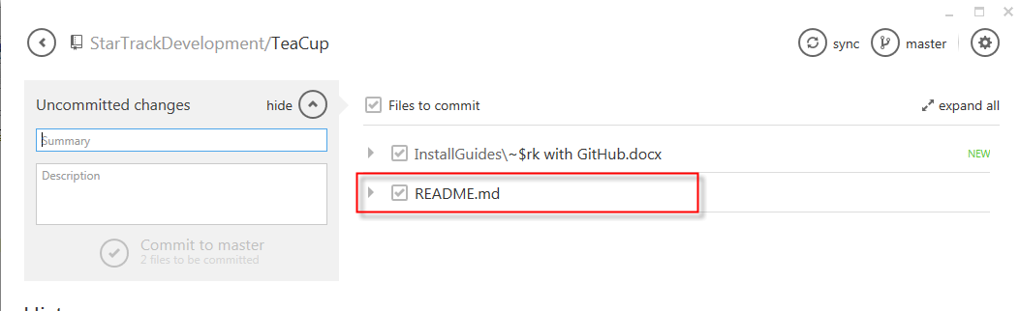

### Expand changes, click on the arrow

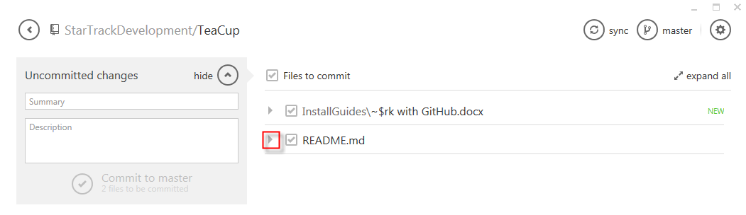

### All changes are shown

Red is deleted, green is new.

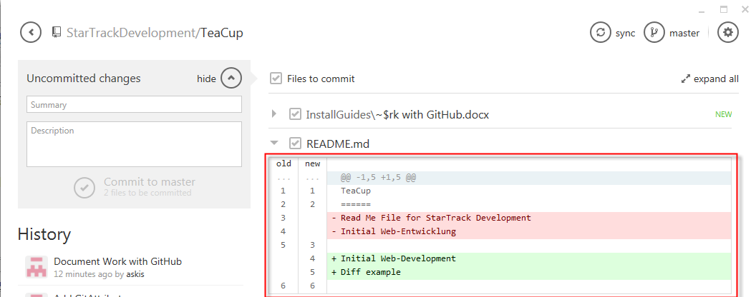

### Commit our changes and push it to the online repository

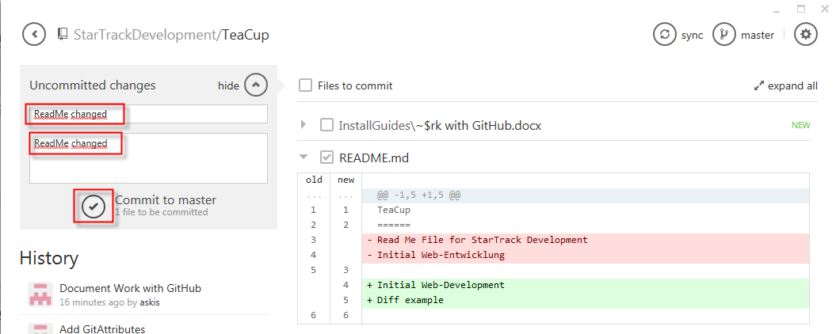

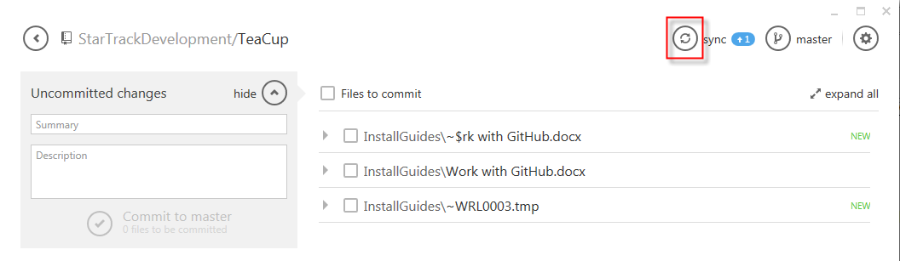

### Click on “ReadMe changed” in your History list

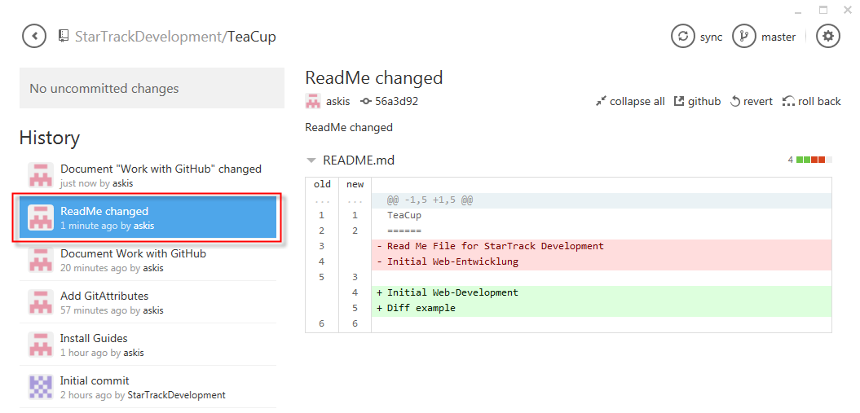

# Create Branches

### Click on the icon shown

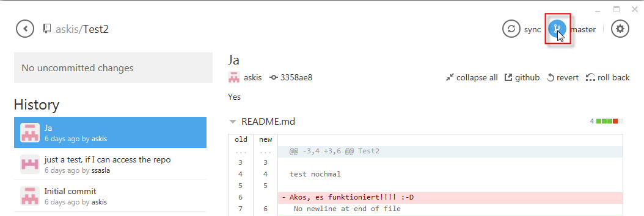

### Type your new Branch name

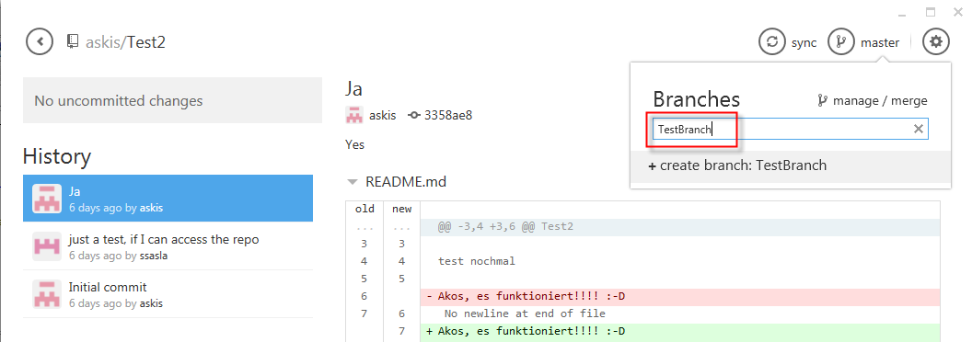

### Click on create branch and your branch is created

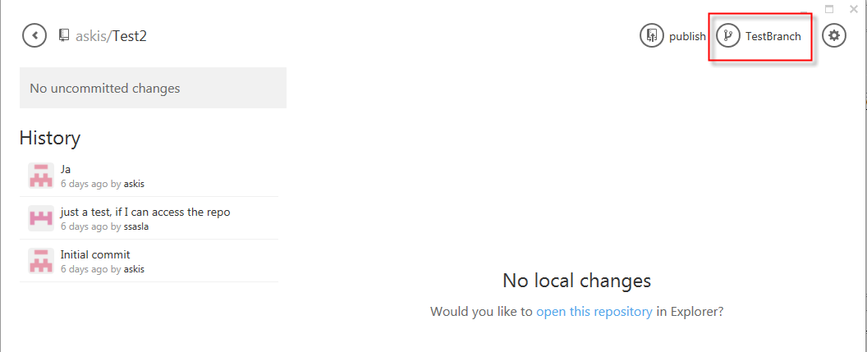

### Click “open this repository” and create a new file

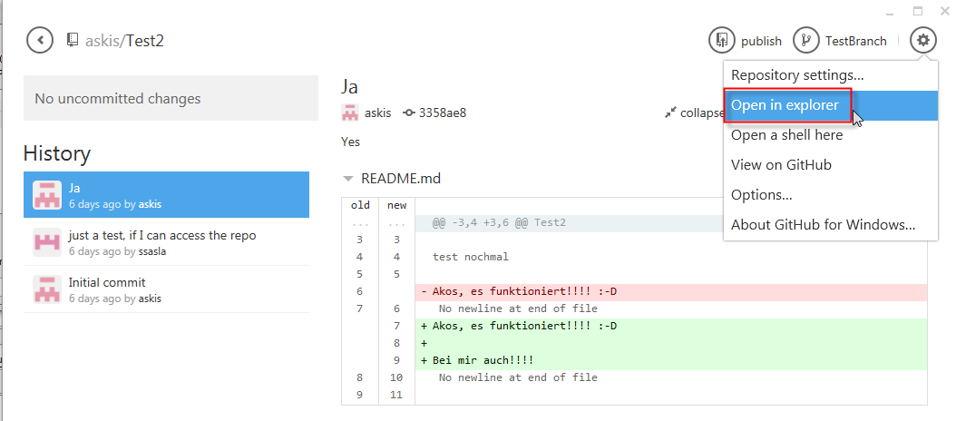

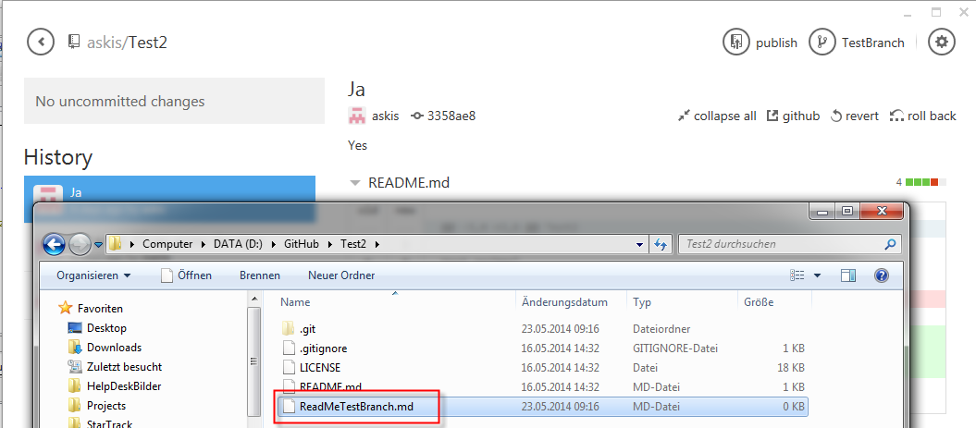

### Commit your change

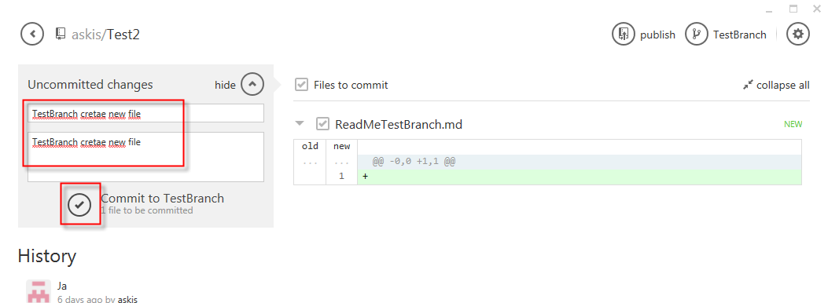

### Commit exists only in TestBranch

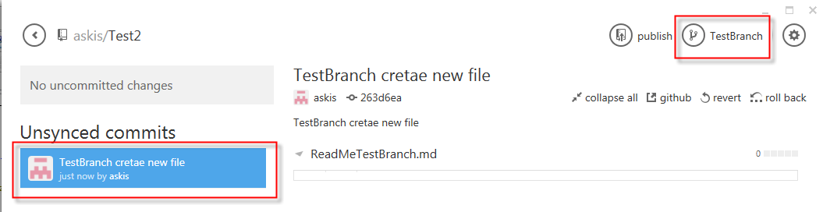

### Switch to master by clicking on TestBranch and choose “master” in the list

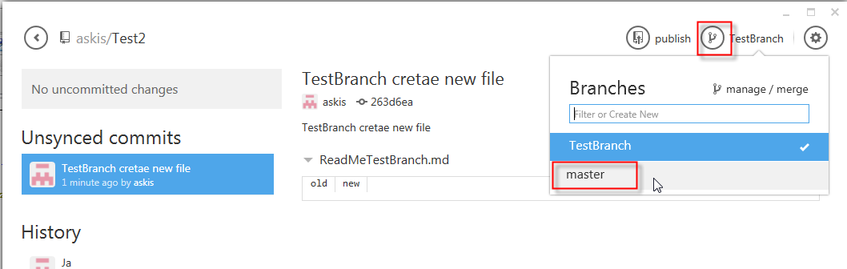

### No changes in “master”

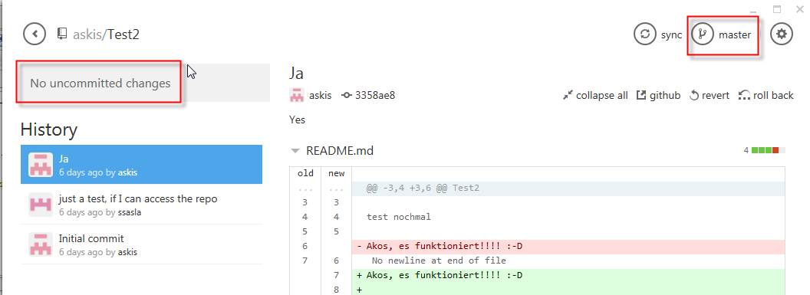

### Go back to “TestBranch”

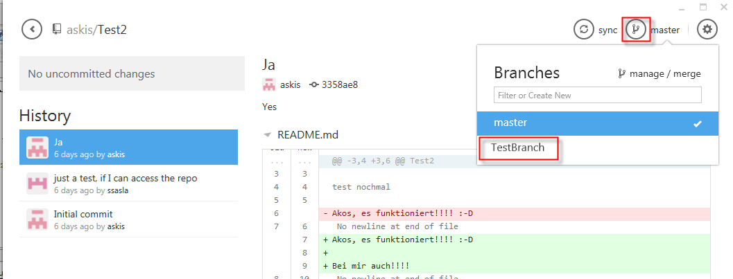

### Publish your change

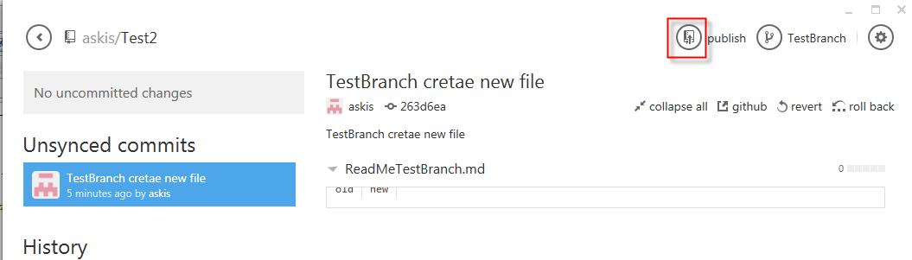

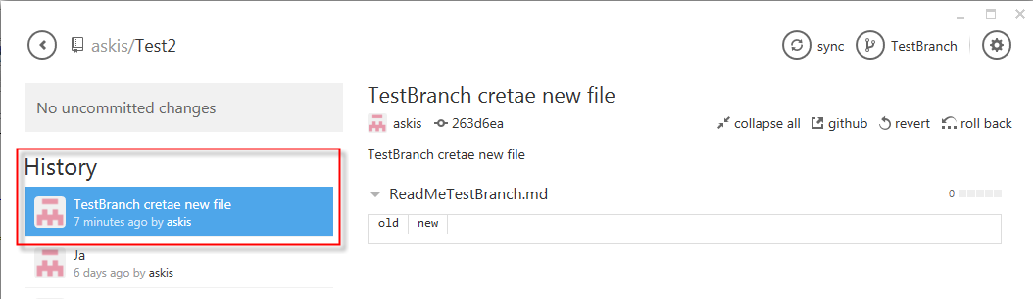

# Merge Branches

### Click on “switch branches” “manage / merge”

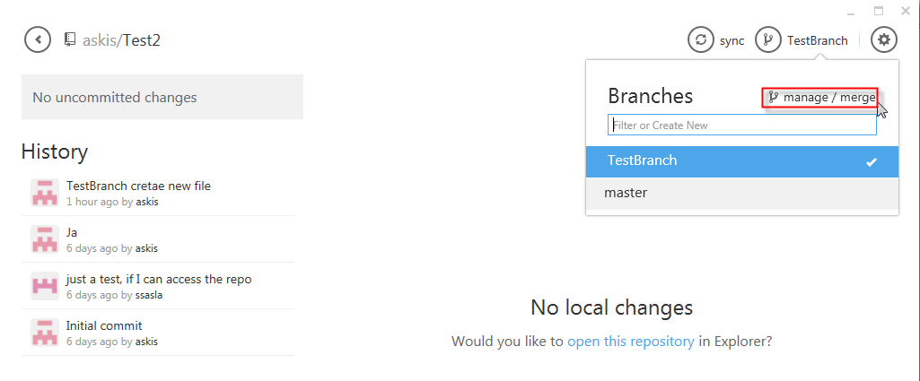

### Choose your source and destination branches (simple drag your branches)

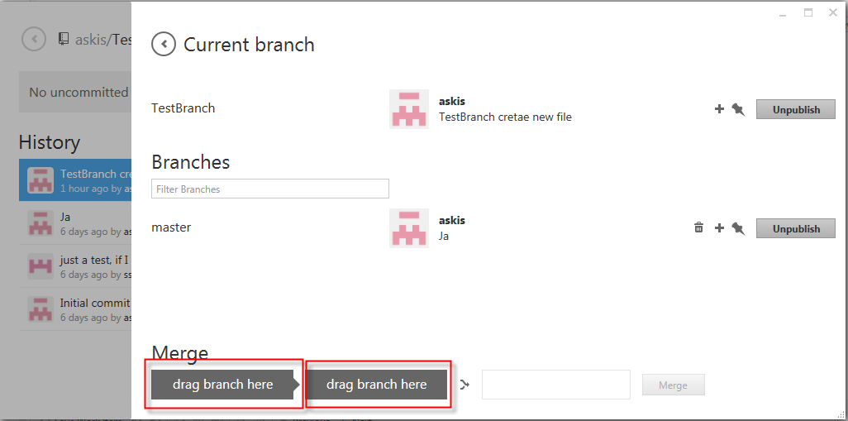

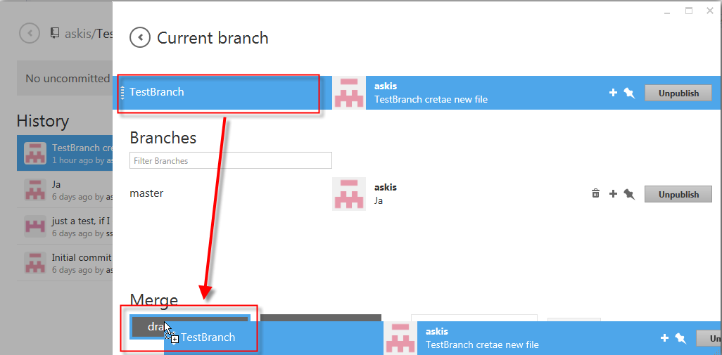

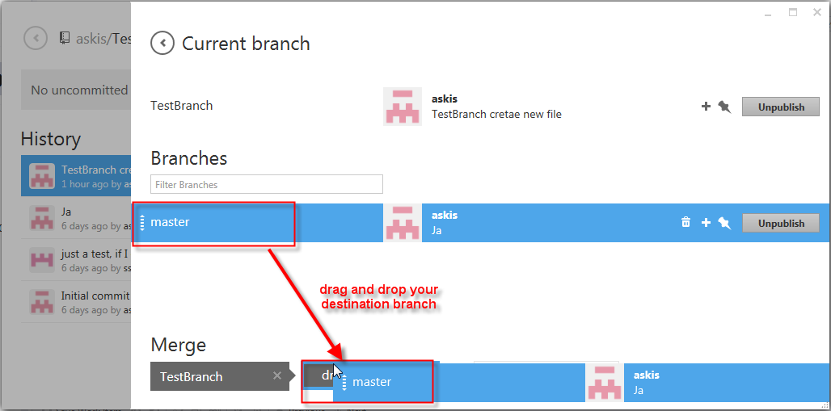

### Merge your branches by clicking on “Merge”

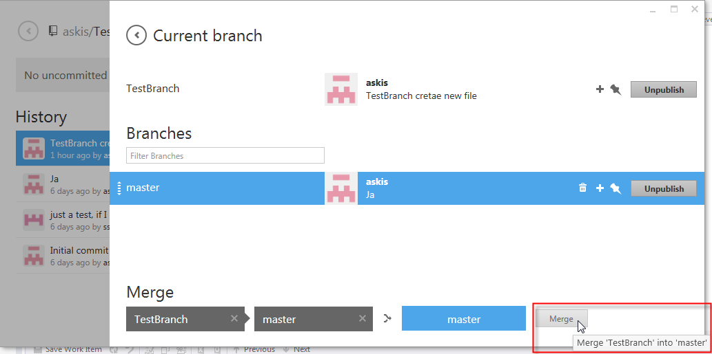

### Message for success merge

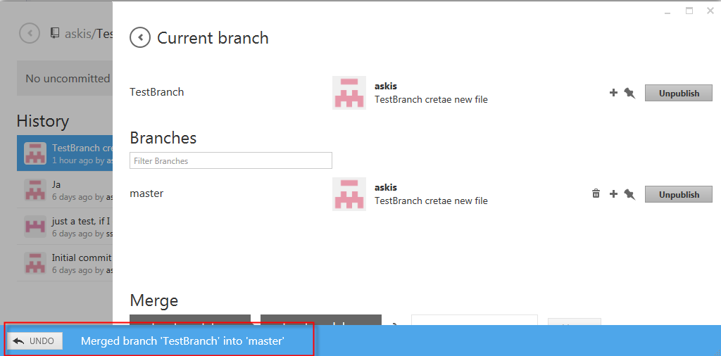

### Go Back and switch to “master”

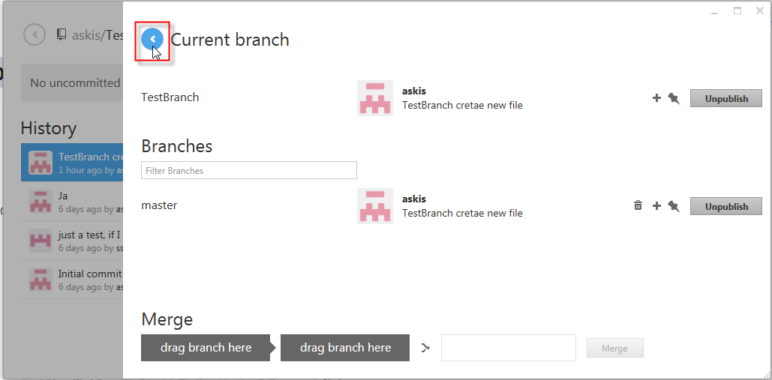

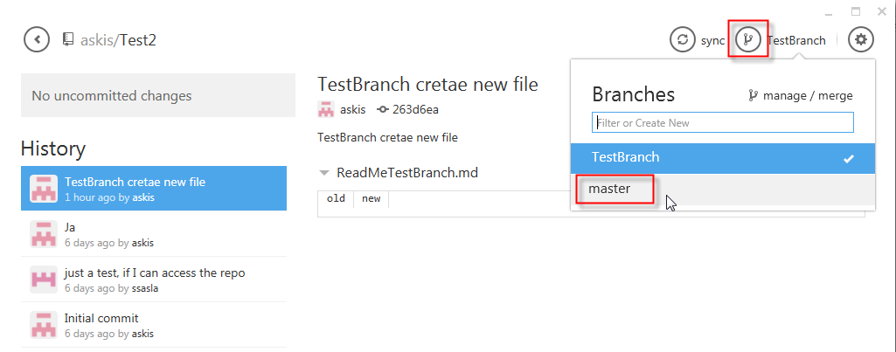

### You should see in the History list the commit that we made in “TestBranch”

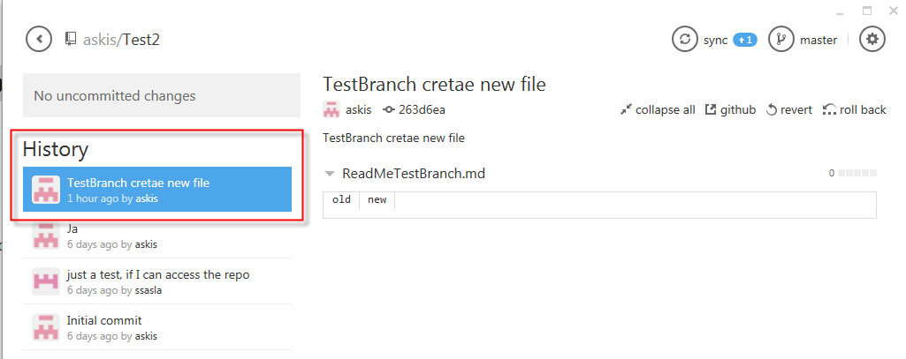

### Sync it with GitHub to “publish” the change

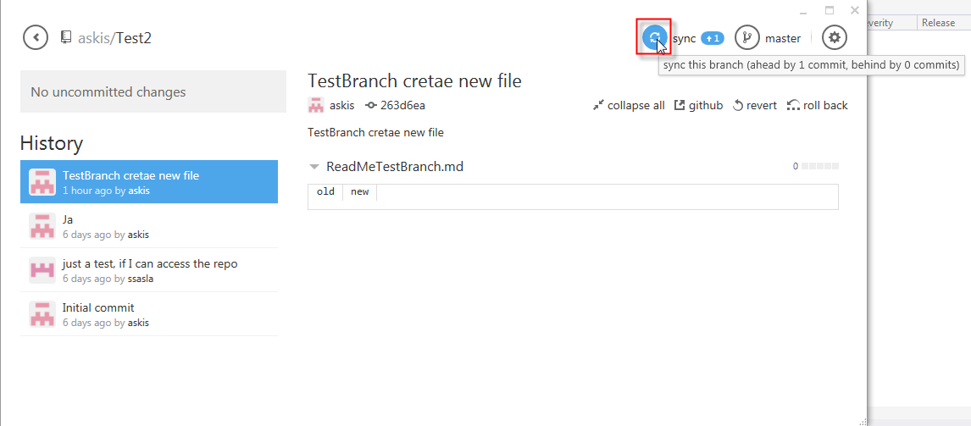

### The new file “ReadMeTestBranch” is online now

